**Task No. 1:** Which type of sorting you want to apply? Create a menu having the following options:

1. Bubble Sort Method
2. Selection Sort Method
3. Insertion Sort Method

Implement using methods.

**Solution:**

class Program

{

public static void BubbleSort(int[] a)

{

int k;

int temp;

for (int i = 0; i < a.Length; i++)

{

for (int j = 0; j < a.Length - 1; j++)

{

k = j + 1;

if (a[j] > a[k])

{

temp = a[j];

a[j] = a[k];

a[k] = temp;

}

}

}

foreach (int item in a)

{

Console.Write(item + " ");

}

Console.WriteLine();

}

public static void SelectionSort(int[] a)

{

int temp, smallest;

for (int i = 0; i < a.Length - 1; i++)

{

smallest = i;

for (int j = i + 1; j < a.Length; j++)

{

if (a[j] < a[smallest])

{

smallest = j;

}

}

temp = a[smallest];

a[smallest] = a[i];

a[i] = temp;

}

foreach (int item in a)

{

Console.WriteLine(item + " ");

}

}

public static void InsertionSort(int[] a)

{

for (int i = 0; i < a.Length - 1; i++)

{

for (int j = i + 1; j > 0; j--)

{

if (a[j - 1] > a[j])

{

int temp = a[j - 1];

a[j - 1] = a[j];

a[j] = temp;

}

}

}

foreach (int item in a)

{

Console.WriteLine(item + " ");

}

}

static void Main(string[] args)

{

Console.WriteLine("Enter Limit of array");

int limit = int.Parse(Console.ReadLine());

int[] input = new int[limit];

Console.WriteLine("Enter array list of number.");

for (int i = 0; i < limit; i++)

{

Console.Write("Enter num for index [" + i + "]=");

input[i] = int.Parse(Console.ReadLine());

}

int[] arr = new int[limit];

Console.WriteLine("What type of Sorting you want to Perform?");

Console.WriteLine("1-Bubble Sort\n2-Selection Sort\n3-Insertion Sort");

Console.WriteLine("Please Enter Num!");

int opt = int.Parse(Console.ReadLine());

int a = 3;

switch (opt)

{

case 1:

BubbleSort(input);

break;

case 2:

SelectionSort(input);

break;

case 3:

InsertionSort(input);

break;

default:

Console.WriteLine("Ooops!!\nInvalid Entry!\nPlease Enter num from 1-3.");

break;

}

}

}

}

**Output:**

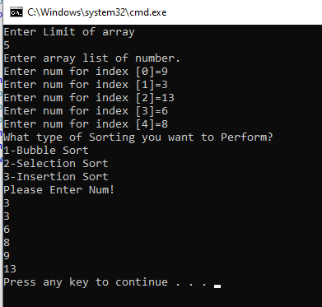

**Task No. 2:** Implement Selection sort and print string array data in descending order

**Solution:**

class Program

{

static void Main(string[] args)

{

Console.WriteLine("Unsorted List of String!");

string[] arr = { "abc", "def", "ghi", "jkl", "mno" };

foreach (string item in arr)

{

Console.Write(item + " ");

}

Console.WriteLine();

int smalest;

string temp;

for (int i = 0; i < arr.Length - 1; i++)

{

smalest = i;

for (int j = i + 1; j < arr.Length; j++)

{

if (string.Compare(arr[j], arr[smalest]) > 0)

{

smalest = j;

}

temp = arr[smalest];

arr[smalest] = arr[i];

arr[i] = temp;

}

}

Console.WriteLine("\nSorted List in Descending Order");

foreach (string item in arr)

{

Console.Write(item + " ");

}

Console.ReadLine();

}

}

}

**Output:**

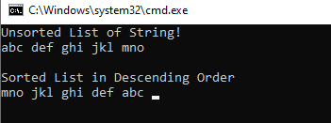

**Task No. 3:** A Detox chemical Industry has a list of chemicals along with their concentration and Volume. Your task is to list down the name of chemicals in descending order based on their Volume. In order to fulfil the task you have to select any of the sorting method taught in today’s lab with proper reasoning of usage of that algorithm.

**Solution:**

class Program

{

static void Selection_Sort(String[,] arr)

{

String temp, volume, concentration;

for (int i = 0; i < (arr.Length / 3) - 1; i++)

{

for (int j = i + 1; j > 0; j--)

{

float b = float.Parse(arr[j - 1, 2]);

float f = float.Parse(arr[j, 2]);

if (b < f)

{

temp = arr[j - 1, 0];

arr[j - 1, 0] = arr[j, 0];

arr[j, 0] = temp;

concentration = arr[j - 1, 1];

arr[j - 1, 1] = arr[j, 1];

arr[j, 1] = concentration;

volume = arr[j - 1, 2];

arr[j - 1, 2] = arr[j, 2];

arr[j, 2] = volume;

}

}

}

}

static void Main(string[] args)

{

String[,] a = new String[5,3];

Console.WriteLine("----Chemicals----");

for (int i = 0; i < a.Length / 3; i++)

{

Console.Write("{0} Chemical = ", i);

a[i, 0] = Console.ReadLine();

Console.Write(" Concentration = ");

a[i, 1] = Console.ReadLine();

Console.Write(" Volume = ");

a[i, 2] = Console.ReadLine();

}

Console.WriteLine();

Console.WriteLine("----Array After Sorting----");

for (int i = 0; i < a.Length / 3; i++)

{

Console.Write(" " + a[i, 0] + " " + "\t" + a[i, 1] + " " + "\t" + a[i, 2]);

Console.WriteLine();

}

Console.WriteLine();

Selection_Sort(a);

Console.WriteLine("----Array In Descending Order----");

for (int i = 0; i < a.Length / 3; i++)

{

Console.Write(" " + a[i, 0] + " " + "\t" + a[i, 1] + " " + "\t" + a[i, 2]);

Console.WriteLine();

}

Console.WriteLine();

}

}

**Output:**

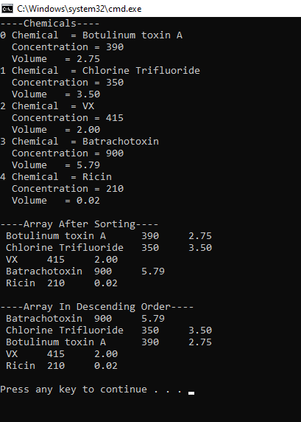

**Task No. 4:** You have to write a program which take input from the user and place the value on correct location in ascending order.

**Solution:**

class Program

{

static void Main(string[] args)

{

Console.WriteLine("Enter limit of array?");

int limit = int.Parse(Console.ReadLine());

int[] arr = new int[limit];

for (int i = 0; i < limit; i++)

{

Console.Write("Enter value for index[" + i + "]=");

arr[i] = int.Parse(Console.ReadLine());

}

Console.WriteLine();

int n = arr.Length;

int k;

for (int m = n; m >= 0; m--)

{

for (int i = 0; i < n - 1; i++)

{

k = i + 1;

if (arr[i] > arr[k])

{

int temp;

temp = arr[i];

arr[i] = arr[k];

arr[k] = temp;

}

}

}

Console.WriteLine("Sorted values");

foreach (int value in arr)

{

Console.Write(value + " ");

}

Console.WriteLine();

}

}

}

**Output:**

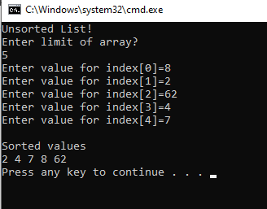

**Task No. 5:** Write a program which take N numbers of grocery items from user along with their price. Your main task is to display the items in sorted format. Then allow user to search for any of the item from that list by using name of the item.

**Solution:**

class Program

{

public static void LinearSearch(String[,] Arr, String item)

{

for (int i = 0; i < Arr.Length / 2; i++)

{

if (Arr[i, 0].ToLower() == item.ToLower())

{

Console.WriteLine("Item Found at {0}", i);

Console.WriteLine(Arr[i, 0] + " " + Arr[i, 1]);

}

}

}

static void Selection_Sort(String[,] arr, int n)

{

int smallest;

String temp, price;

for (int i = 0; i < n / 2; i++)

{

smallest = i;

for (int j = i + 1; j < n; j++)

{

if (arr[i, 0].ToLower().First() < arr[smallest, 0].ToLower().First())

{

smallest = j;

}

}

temp = arr[smallest, 0];

arr[smallest, 0] = arr[i, 0];

arr[i, 0] = temp;

price = arr[smallest, 1];

arr[smallest, 1] = arr[i, 1];

arr[i, 1] = price;

}

}

static void Main(string[] args)

{

String[,] a = new String[10, 2];

Console.WriteLine("----Grocery Items----");

for (int i = 0; i < a.Length / 2; i++)

{

Console.Write("{0} Name = ", i);

a[i, 0] = Console.ReadLine();

Console.Write("{0} Price= ", i);

a[i, 1] = Console.ReadLine();

} Console.WriteLine();

Console.WriteLine("----Array After Sorting----");

Selection_Sort(a, a.Length);

for (int i = 0; i < a.Length / 2; i++)

{

Console.Write(a[i, 0] + " " + a[i, 1]);

Console.WriteLine();

}

Console.WriteLine();

Console.Write("Input Search = ");

string input = Console.ReadLine();

LinearSearch(a, input);

}

}

}

**Output:**

